Your Media.com Profile
Cover Page
Full Name | CHANTELLE BAIER
Profile photo | I like the one you used in the template
Header image | 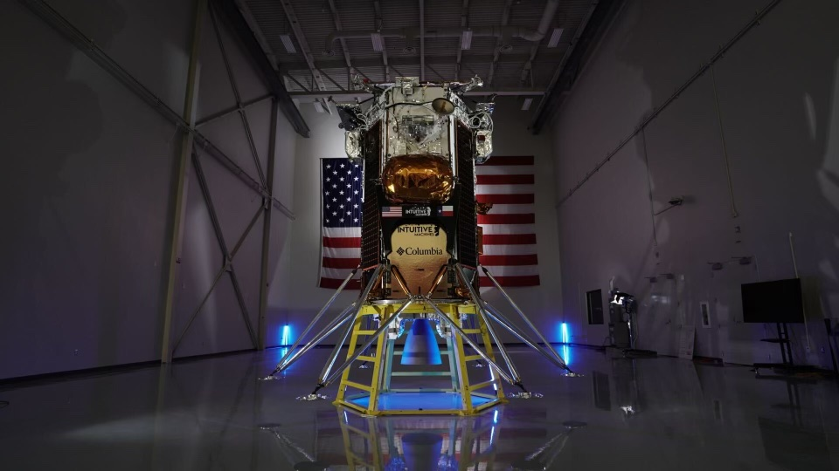
Job Title | Founder & CEO at 4SPACE LLC
Short bio | I’m getting ready to send the first art gallery to the moon.
About Me > Overview
Long bio | 2-3 paragraphs about you
Date of Birth | Optional
Location of Birth | Canada
Favourite quote | “Shoot for the Moon. Even if you miss, you’ll land among the Starts” – Norman Vincent Peale
What you’re working on | Missions to the Moon. I’m at the forefront of an exciting venture that intertwines the beauty of exploring the moon with the vibrant world of art. The title is “Jeff Koons Moon Phases”. This pioneering project aims to establish the first art gallery on the moon, a ground-breaking achievement.  I’m also working with an exclusive artist to bring his contemporary style to celebrate and transcend above the boundaries we place on Earth.  We’re also working on an exclusive launch party to commemorate this historic time.
Your interests | SPACE, ART, FILM, FASHION, SPARK,
Greatest achievement | Reflecting upon the intricate tapestry of my endeavors, I must say my paramount accomplishment lies not within the celestial bounds of my lunar gallery, a testament to humanity set to historically hold on the moon. Rather, it is found in the earthly realm of nurturing a brilliantly kind daughter. Her curious mind and compassionate heart are like the stars that we reach for which truly represent my most profound manifestation of aspirations.
Languages you speak | English
Favorite book(s) | The Next Space Race – A Blueprint for American Primacy – by Richard M. Harrison and Peter A. Garretson
Favorite song
Favorite sport | Boxing (okay, it’s been many years since I’ve boxed with Manny Pacquiao, however, it’s still my favorite sport, second is Soccer.
Favorite things to do | Explore, Learn, and help Kids
About Me > Gallery
12 photos of you | These will be displayed in a gallery format
About Me > Experience | Started a space company that aims to bridge the world we live in with the exclusive world of NASA. I built up my company with a focus on how to utilize space technology to help the world. As I worked with Procter and Gamble to develop their Sustainability Pavillion in Davos WEF2020, this allowed me to push the boundaries of SPACE integration with Enterprise entities. We used AR to tell their story and to demonstrate new ways of production that can cut down on cost and waste. I’ve built out STEAM programs for P&G, SPARK Series for Ad Astra School, Elon Musk’s Privat school, and locked in my contracts for developing projects that will be placed on the moon.
Work History | Job Title Company From Date To Date Location Basis  Founder & CEO 4Space LLC 2017 Current Los Angeles Full-time
Email address | Chantelle@4Space.co
Phone number | Preferably a landline or work number
Social network URLs | LinkedIn -  Facebook -  X -  Instagram -  YouTube -  TikTok -  Other -
Topics
For each topic | Topic Name:  Topic Image (please insert)  Who is involved in the topic (Name, Company, Position, 2-3 sentence description of their role, profile photo)  What occurred or is going to occur (provide detail about the topic – this can be multiple pages broken into headings & sub-headings)  Timeline (for each event on the timeline provide Date, Event, Description, Image (optional))  Documents provide any supporting documents (e.g. certificates, awards, contracts etc.)  FAQ (up to 30 questions and answers about the Topic)
Releases
Media releases | Please provide up to 5 draft media releases (we can refine the wording prior to launch)
Responses
Media responses | URLs of 3 articles you would like to respond to. For each article please copy the relevant snippet(s) of text you would like to respond to and provide up to a 3 sentence response per snippet

